How to subscribe to the Vattenfall Energy Award group:
- Go to https://www.kth.se/social/group/the-vattenfall-energ/

- Click the subscribe button
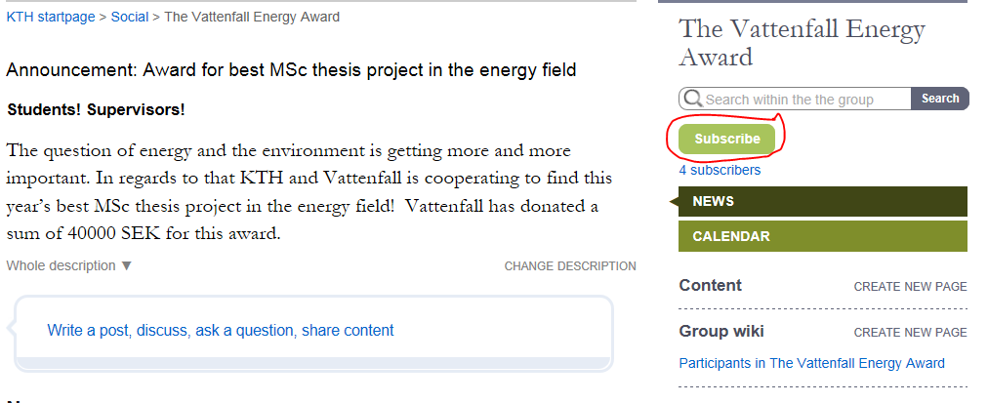

- Edit subscription (set at least as getting daily notifications)
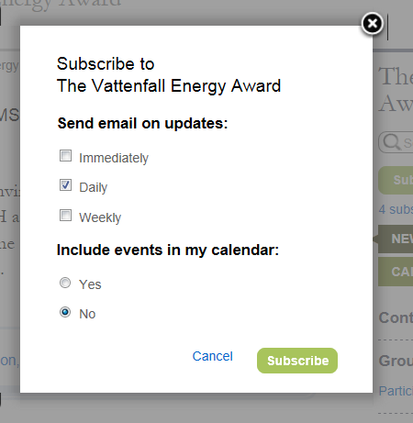

Now you have taken the first steps to entering in the contest.

