How to edit and activate your profile
- Go to www.kth.se

- Go to Social:
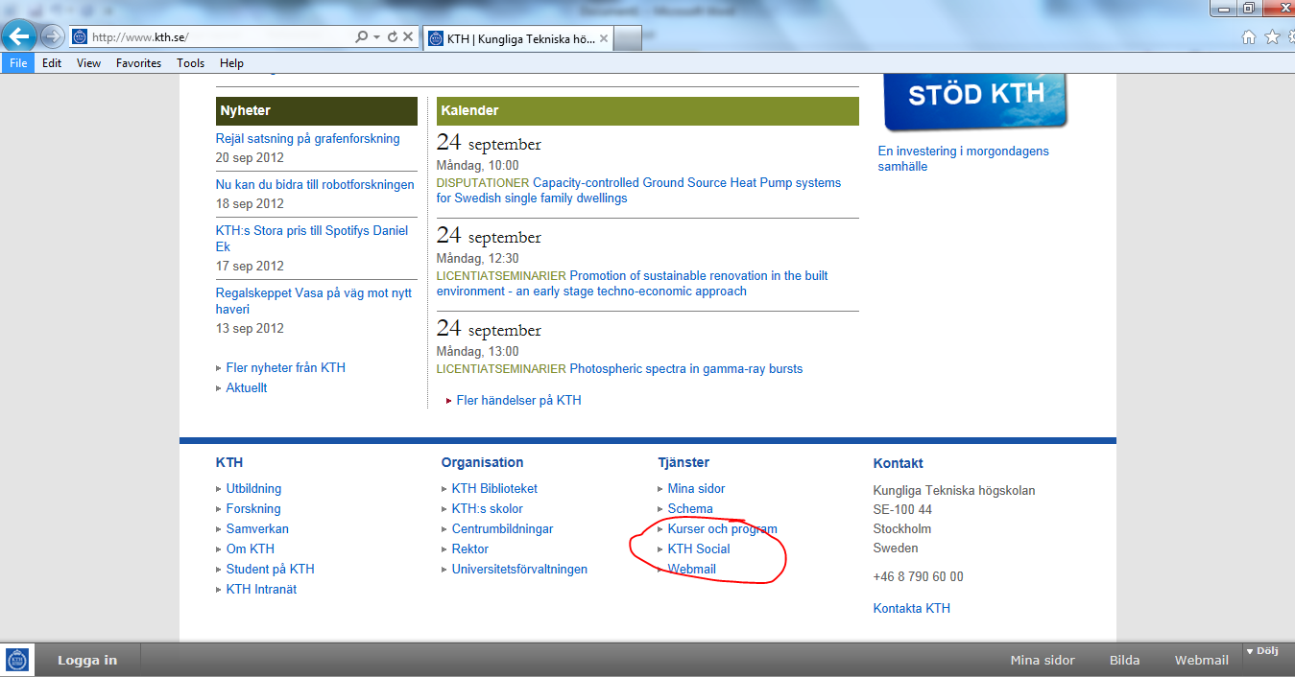

- Log in:
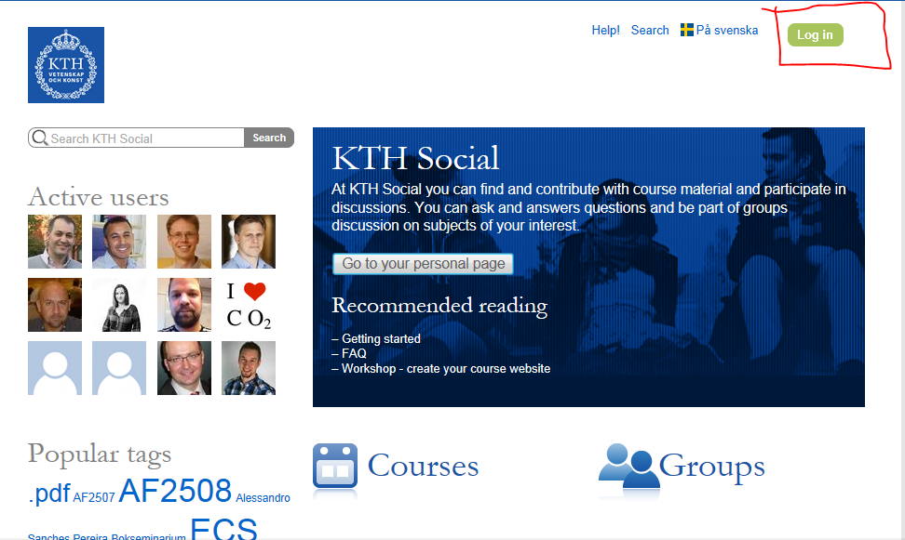

- Go to your Profile:
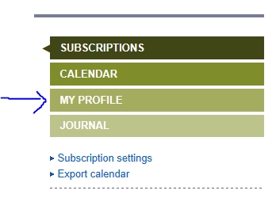
- Click on “EDIT MY PROFILE”
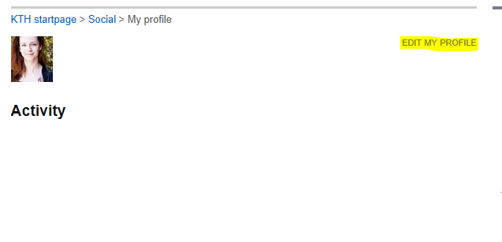

- Edit your profile, post a picture and save
