## Thesis proposal – Partial Replacement of Cement in Interlocking Bricks

**Background**

*Engineers without Borders (EWB) in Sweden* is an NGO focused on engineering solutions and sustainable technology at the heart of the green transition. EWB is partner of *Build up Nepal (BUN),* that was established following the 2015 earthquake in Kathmandu. BUN focuses on promoting compressed bricks made from a mixture of stone dust or soil, cement, and water. These bricks are produced using machines provided to small enterprises. Since its inception, BUN has supported over 300 small companies, contributing to the construction of more than 10,000 houses across Nepal. Their efforts have significantly reduced carbon emissions by 100,000 tonnes and created over 2,000 full-time jobs, with women making up a quarter of the workforce. Interlocking bricks, designed like LEGO blocks, are BUN's main product. These bricks are not only easy to assemble but are also earthquake-resistant, making them particularly suitable for construction in earthquake-prone regions like Nepal.

**Scope of work**

Cement is the main driver of cost and emissions in the interlocking bricks promoted by BUN. The primary objective of this work is to partially substitute cement with alternative binders or supplementary cementitious materials (SCMs), such as brick dust and Rice Husk Ash (RHA), which are readily available in Nepal. Cooperation with a private laboratory for grinding brick dust using a ball mill and initial testing has commenced. Testing will be conducted in BUN’s workshop, equipped for compressive strength testing. The scope of work includes determining the extent of cement substitution that maintains effective performance, assessing variability in quality and evaluating the economic viability of these substitutions based on available data. This effort aims to achieve cost reduction while ensuring quality control and performance of the interlocking bricks.

This work should preferably be done in Kathmandu at BUN.   
Contact person: [Ashish Maharjan](mailto:ashish.m@buildupnepal.com)

**Further information**

Contact can be taken with [Linn Bogren](mailto:linn.bogren@live.se) who finished a study on brick strength optimisation based on water content and compression in 2024. Also take part of her [Travel dairy](https://www.ewb-swe.org/stories).

You can also contact [Henrik Gustavsson](mailto:henrik.gustavsson@ewb-swe.org) project manager for EWB BUN cooperation and [Raine Isaksson](mailto:raine.isaksson@ewb-swe.org) Associate professor in Quality Management and EWB member working actively with BUN.

**Some illustrations of the work process**

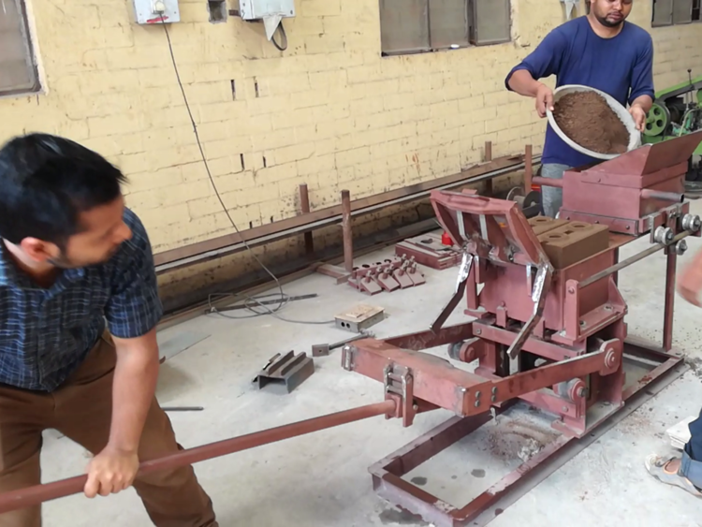

[Video from YouTube](https://youtu.be/kI8kaVeosds) for further background.