## Thesis proposal – Optimising the Mix of Interlocking Bricks

**Background**

*Engineers without Borders (EWB) in Sweden* is an NGO focused on engineering solutions and sustainable technology at the heart of the green transition. EWB is partner of *Build up Nepal (BUN),* that was established following the 2015 earthquake in Kathmandu. BUN focuses on promoting compressed bricks made from a mixture of stone dust or soil, cement, and water. These bricks are produced using machines provided to small enterprises. Since its inception, BUN has supported over 300 small companies, contributing to the construction of more than 10,000 houses across Nepal. Their efforts have significantly reduced carbon emissions by 100,000 tonnes and created over 2,000 full-time jobs, with women making up a quarter of the workforce. Interlocking bricks, designed like LEGO blocks, are BUN's main product. These bricks are not only easy to assemble but are also earthquake-resistant, making them particularly suitable for construction in earthquake-prone regions like Nepal.

**Scope of work**

In 2024, an [exam work](https://www.diva-portal.org/smash/record.jsf?pid=diva2%3A1880292&dswid=239) by Linn Bogren revealed that increasing the water content in the brick mix could significantly enhance strength due to improved workability. A specific change from 6% to 10% water content demonstrated a doubling of strength. In response, BUN has decided to set a new target mix of 8% water with 7% cement, down from the previous 10% cement. BUN has also begun retraining enterprises on this new method, which will be followed by continuous monitoring to ensure consistency. The key question is whether more water can be added to the mix while considering potential risks such as bricks breaking during production, alterations in surface texture and changes in other performance parameters. The compressive strength must be maintained at the target level with minimal variation. The ultimate objective is to reduce cement content further without compromising brick quality, primarily measured by compressive strength.

The work can be done in Nepal or in Sweden with preference for work in Kathmandu at BUN.   
Contact person: [Ashish Maharjan](mailto:ashish.m@buildupnepal.com)

**Further information**

Contact can be taken with [Linn Bogren](mailto:linn.bogren@live.se) who finished a study on brick strength optimisation based on water content and compression in 2024. Also take part of her [Travel dairy](https://www.ewb-swe.org/stories).

You can also contact [Henrik Gustavsson](mailto:henrik.gustavsson@ewb-swe.org) project manager for EWB BUN cooperation and [Raine Isaksson](mailto:raine.isaksson@ewb-swe.org) Associate professor in Quality Management and EWB member working actively with BUN.

**Some illustrations of the work process**

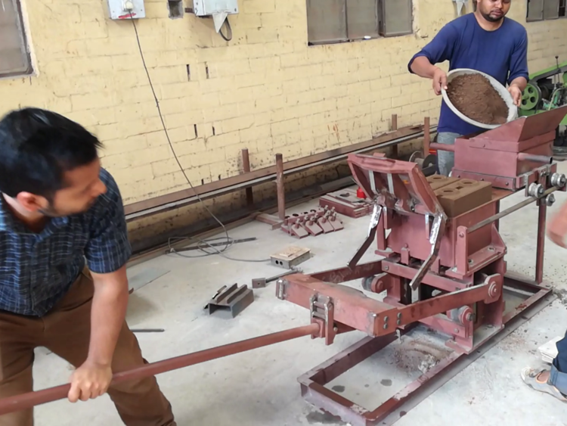

[Video from YouTube](https://youtu.be/kI8kaVeosds) for further background.