## Thesis proposal - Investigating and Mitigating Shrinkage Crack Formation in Interlocking Brick Houses

**Background**

*Engineers without Borders (EWB) in Sweden* is an NGO focused on engineering solutions and sustainable technology at the heart of the green transition. EWB is partner of *Build up Nepal (BUN),* that was established following the 2015 earthquake in Kathmandu. BUN focuses on promoting compressed bricks made from a mixture of stone dust or soil, cement, and water. These bricks are produced using machines provided to small enterprises. Since its inception, BUN has supported over 300 small companies, contributing to the construction of more than 10,000 houses across Nepal. Their efforts have significantly reduced carbon emissions by 100,000 tonnes and created over 2,000 full-time jobs, with women making up a quarter of the workforce. Interlocking bricks, designed like LEGO blocks, are BUN's main product. These bricks are not only easy to assemble but are also earthquake-resistant, making them particularly suitable for construction in earthquake-prone regions like Nepal.

**Scope of work**

The issue of cracks appearing in houses built with interlocking bricks is a significant concern, especially since it tends to be more pronounced compared to houses built with fired red bricks. Experts have identified these cracks as shrinkage related. To effectively address this problem, the project will focus on understanding the underlying causes, such as material properties and environmental factors, and developing strategies to eliminate or minimize crack formation. Additionally, the project may include creating methods for effective monitoring and control of cracks to ensure long-term durability and quality of the structures.

The work can be done in Nepal or in Sweden with preference for work in Kathmandu at BUN.   
Contact person: [Ashish Maharjan](mailto:ashish.m@buildupnepal.com)

**Further information**

Contact can be taken with [Linn Bogren](mailto:linn.bogren@live.se) who finished a study on brick strength optimisation based on water content and compression in 2024. Also take part of her [Travel dairy](https://www.ewb-swe.org/stories).

You can also contact [Henrik Gustavsson](mailto:henrik.gustavsson@ewb-swe.org) project manager for EWB BUN cooperation and [Raine Isaksson](mailto:raine.isaksson@ewb-swe.org) Associate professor in Quality Management and EWB member working actively with BUN.

**Some illustrations of the work process**

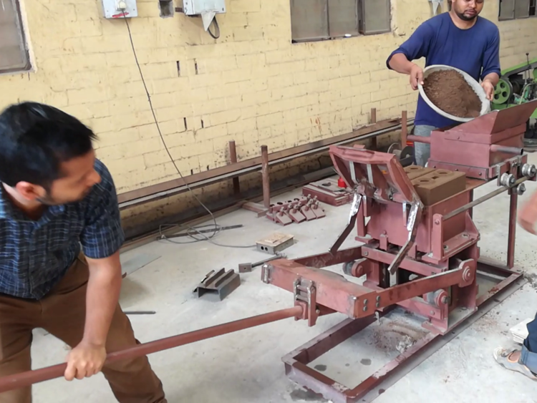

[Video from YouTube](https://youtu.be/kI8kaVeosds) for further background.