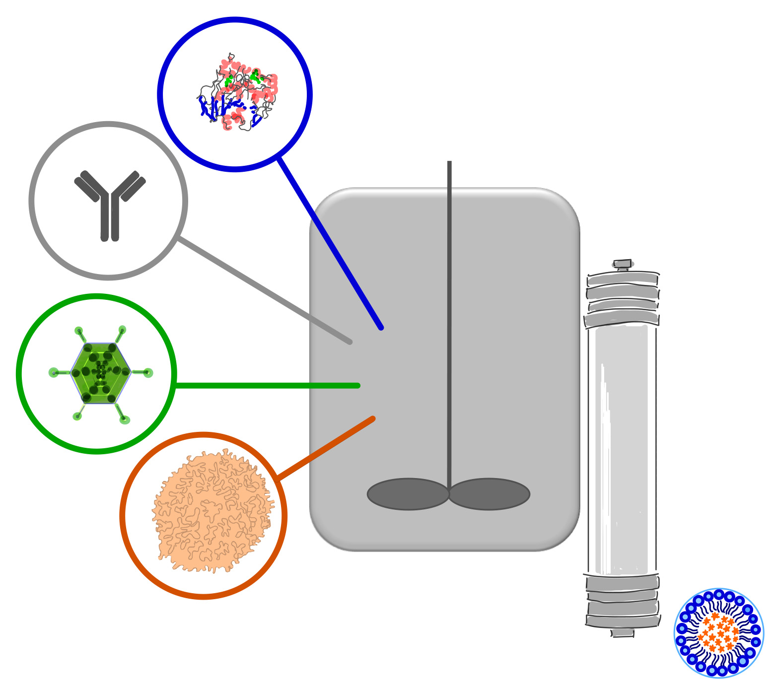

**AdBIOPRO Symposium 2024 Bioproduction of Therapeutic Biologics**

Dear colleague,

AdBIOPRO, VINNOVA Competence Centre for Advanced BioProduction by Continuous Processing, organizes a symposium, AdBIOPRO Symposium 2024 - Bioproduction of Therapeutic Biologics including ATMP’s in Stockholm.

We would like to invite you to this event. As previously, the theme will be Bioproduction of Therapeutic Biologics, covering process development, formulation, characterization, for biologics such as proteins, viral vectors, cells, etc. It will feature achievements of the Competence Centre AdBIOPRO, will ***welcome your contribution*** to the program and will be a great opportunity for networking. This year the event will be also available via webconference (virtual), although attending in person is encouraged since the event will be a very nice opportunity for networking.

AdBIOPRO is a Competence Centre focusing on Advanced BioProduction by Continuous Processing focusing on biologics produced by mammalian/human cells, including cells as products, a collaboration of groups from KTH (Prof. Veronique Chotteau, Prof. Sophia Hober, Prof. Johan Rockberg, Prof. Torbjörn Gräslund, Prof. Håkan Hjalmmarsson, Prof. Elling Jacobsen), Lund University (Prof. Bernt Nilsson), Karolinska Centre for Cell Therapy (Assoc. Prof. Pontus Blomberg), Karolinska Institutet (Assoc. Prof. Evren Alici), Linköping University (Prof. Daniel Aili), AlfaLaval, ArgusEye, AstraZeneca, BioInvent, BioLamina, Cellcolabs, Cellevate, Cytiva, Merck Breez, MAGic Bioprocessing, MeteNova, NorthX Biologics, Nyctea, TimeGate and Valneva.

*Time*: 10th of June 9:00 to 18:00 and 11th of June 9:00 to 12:30, 2024.

*Venue*: KTH, AlbaNova Centre, Roslagstullsbacken 21, SE114 21 Stockholm, Sweden

**Full list of presenters**

Bioprocesses for human pluripotent stem cells culture, lineage-directed differentiation and application for heart repair by Robert Zweigerdts, Department of Cardiac, Thoracic, Transplantation and Vascular Surgery, Hannover Medical School, Germany

Environmental sustainability and bioprocessing by Alois Jungbauer, University of Natural Resources and Applied Life Sciences (BOKU)

Integration of stem cell-derived pancreatic aggregates into FN-silk network for in vitro maturation by Kelly Blust, Protein Technology, KTH

Heterogeneity in Adeno-Associated Virus Transfection-Based Production Process Limits the Production Efficiency by Sofia Tunmats, Cell Technology group, KTH

Towards an Understanding of Donor-to-Donor Heterogeneity in In Vitro Natural Killer Cell Production by Brian Ladd, Cell Technology group, KTH

Transcriptomics-guided genome scale modeling of the kinetics of CHO cells under perfusion culture by Kévin Colin, Desicion and Control Systems, KTH

Metabolome data for improvement of CHO-cell based bioproduction process performance by Meeri Mäkinen, Cell Technology group, KTH

Purification of biopharmaceuticals on electro-responsive brushes by Hanna Tranchell and Armaghan Romiani, Nyctea Technologies

A novel in-line sensor system for real-time bioprocess monitoring by Erik Martinsson, , ArgusEye

Economic modelling of magnetic bead-based mAb manufacturing by Nils Brechmann, , MAGic Bioprocessing

A scalable single-use two step plasmid purification process by Hans Blom, Cytiva

The Mini, a small Any-Use centrifuge, it’s challenges and possibilities by Peter Thorwid, Alfa Laval

Model-based optimization of culture medium for CHO cell perfusion culture  by Mirko Pasquini, Desicion and Control Systems, KTH

Development of small binders for biotechnological applications by Sophia Hober, Protein Technology, KTH

Exploring bioprocess operation modes for the expansion of human Mesenchymal Stromal Stem Cells by Johanna Pechan, Cell Technology group, KTH

Novel affinity resin: bispecific and fragment antibody purification in focus by Moumita Ghosh Laskar, Cytiva

Cellevat3dTM nanofiber-based microcarriers designed for improved upstream productivity of viral vector biomanufacturing – Laura Chirica and Linda Dexlin Mellby, Cellevate

***REGISTRATION is closed.***

*Fee for in person attendance – hotel stay not included:*

Early bird by May 19th, 2024:

- 0 SEK for AdBIOPRO members (AdBIOPRO members include all personal of any of the partner

organization of AdBIOPRO)

- 1500 SEK (excl. VAT) for industry non-members of AdBIOPRO

- 950 SEK (excl. VAT) for academia non-members of AdBIOPRO

*Late fee for in person attendance by June 3rd, 2024 – hotel stay not included:*

- 2000 SEK (excl. VAT) for industry non-members of AdBIOPRO

- 1500 SEK (excl. VAT) for academia non-members of AdBIOPRO

*Fee for attendance via webconference by June 3rd, 2024:*

- 0 SEK for AdBIOPRO members

- 300 SEK (excl. VAT) for industry or academia non-members of AdBIOPRO

Contact for scientific program: Sofia Renblad (email [renblad@kth.se](mailto:renblad@kth.se)) and Veronique Chotteau (email: chotteau@kth.se) please use mention AdBIOPRO2024 Symposium

Looking forward to meeting you at the AdBIOPRO Symposium 2024!

*Kind regards*

*Veronique Chotteau, Sofia Renblad, Sophia Hober, Johan Rockberg, Torbjörn Gräslund, Håkan Hjalmarsson, Elling Jacobsen, Bernt Nilsson, Pontus Blomberg, Evren Alici, Daniel Aili*

